Name:________________________

Date:_________________________

1.

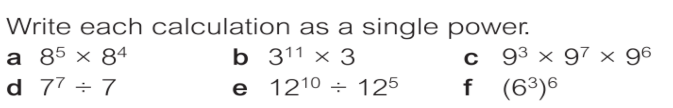

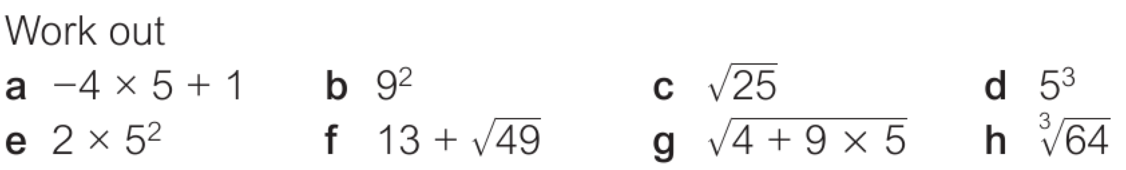

3.

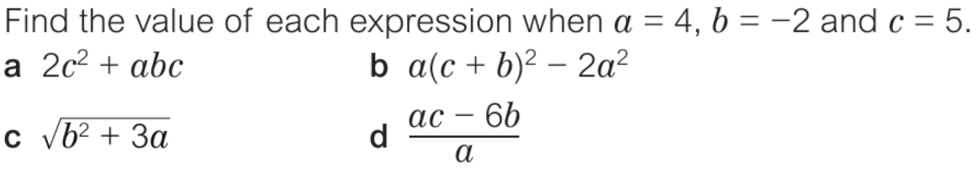

4.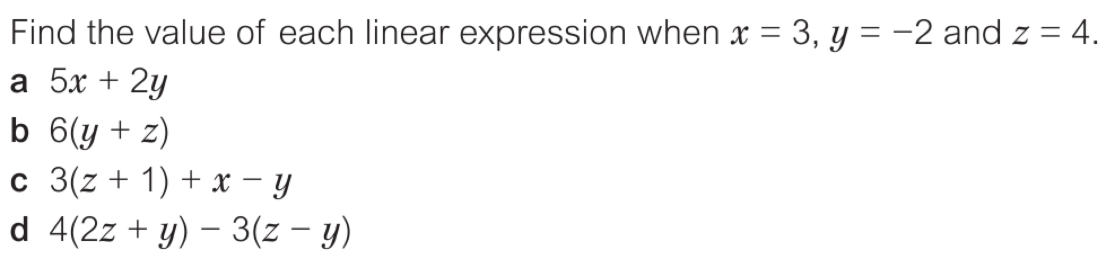

5.

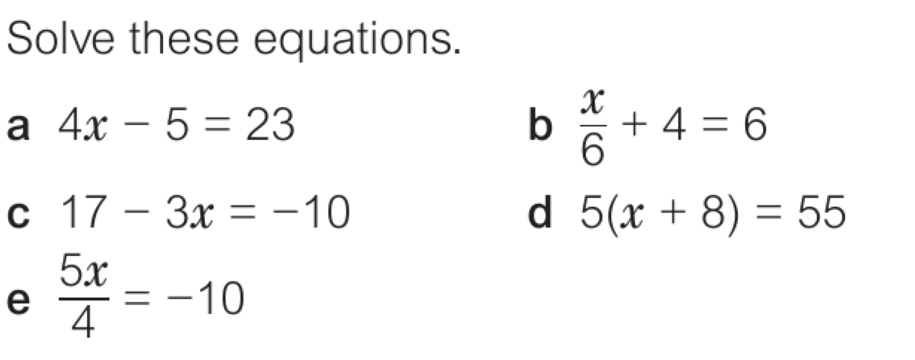

6.

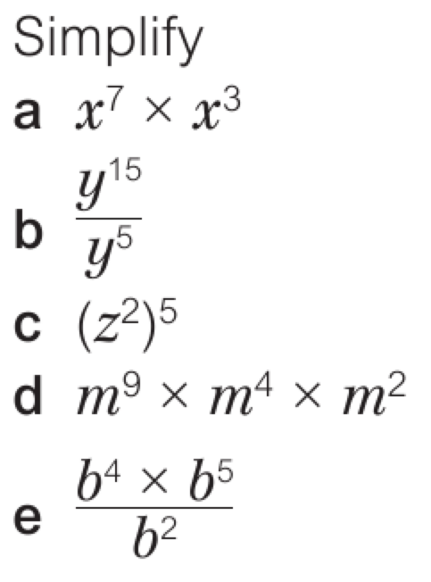

7.

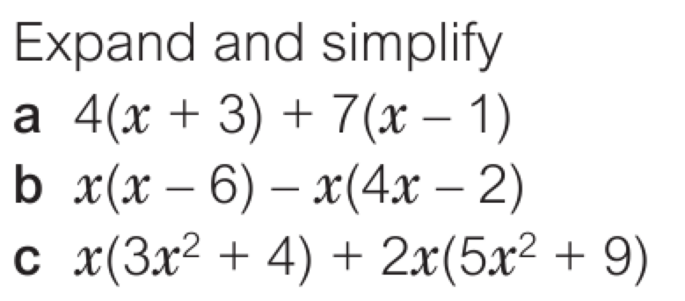

8.

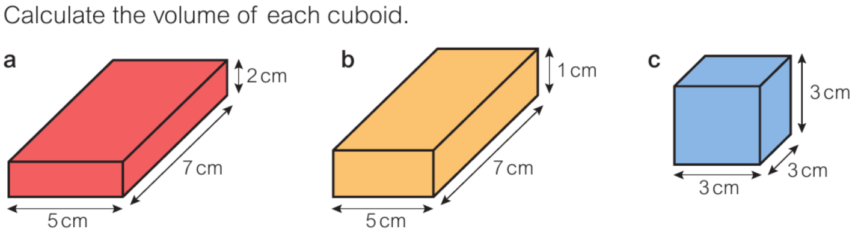

9.

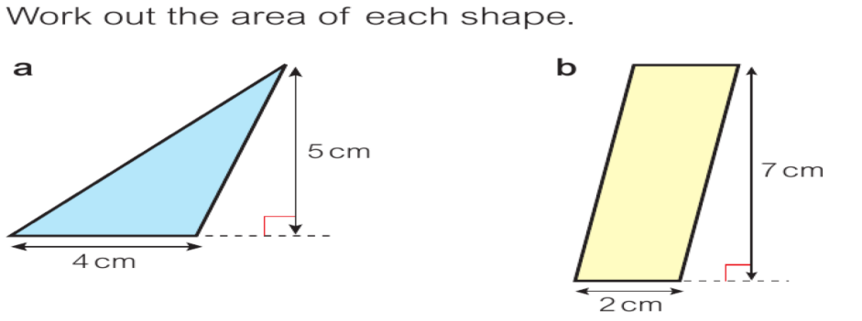

10.

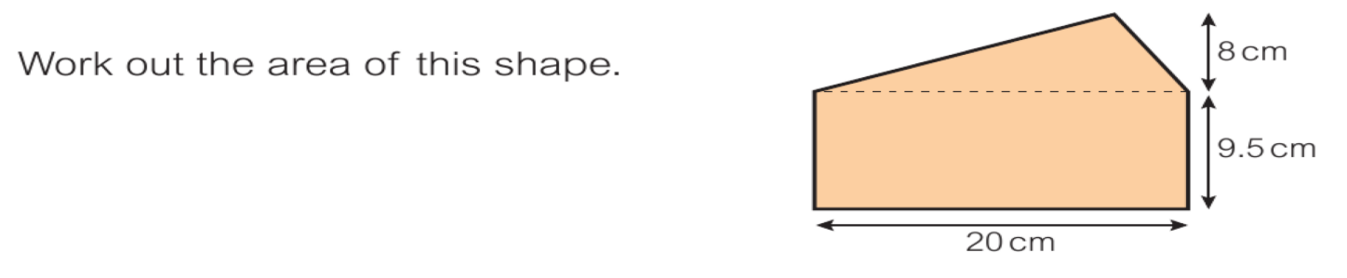

11.